RECYCLING & Drop-Off Locations
Lancaster
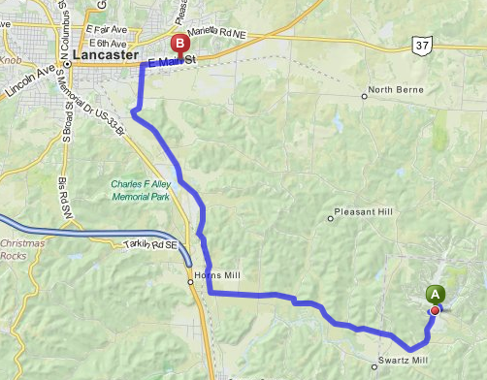
Recycling Center
1761 East Main Street
Lancaster, Ohio 43130
(740) 687-1295
Drive thru hours:
Hours M-F 9AM-5PM Sat 8AM-1PM
Drop Off Containers 24HR

Turn right onto Hide-A-Way Hills Rd. (go 1.57 miles). Hide-A-Way Hills Rd becomes Horns Mill Rd. (go 1.95 miles) Turn left to stay on Horns Mill Rd. Turn right onto Sugar Grove Rd SE. (go 3.91 miles) Stay straight to go onto S Ewing St. (go 1.08 miles) Turn right onto E Main St 1761 E MAIN ST is on the left.

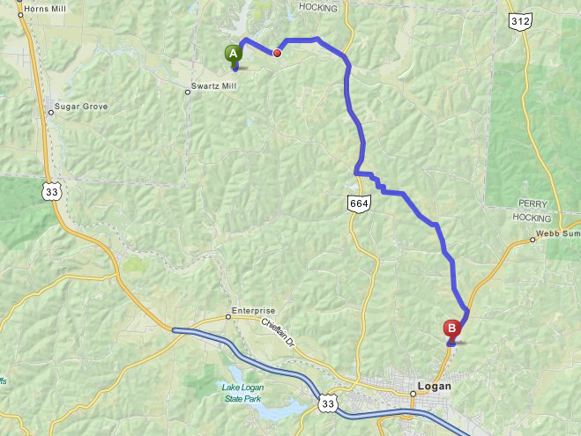
Logan
Hocking County Recycling Center
33845 Sutton Road
Logan, OH
Phone: (740) 385-7386

Start out going southeast on Hide-A-Way Hills Rd (go 2.33 miles).Turn slight right onto OH-664. (go 2.59 miles) Turn left onto Logan Horns Mill Rd. (go 0.32 miles). Turn right to stay on Logan Horns Mill Rd. (go 1.99 miles). Turn right onto Bremen Rd. (go 1.98 miles). Turn right onto OH-93. (go 0.8 miles). Take the 2nd left onto Sutton Rd. (go 0.17 miles). 33845 SUTTON RD is on the right.

FAIRFIELD COUNTY DROP OFF TRAILERS
The following recyclables are accepted in each of the 22 trailers located throughout Fairfield County:

ALUMINUM CANS
(Drain, rinse and place in aluminum / steel can bin)

STEEL CANS
(Vegetable, cat food, soup cans etc. Drain, rinse and place in aluminum / steel can bin)

GLASS BOTTLES AN D JARS ONLY
(Drain, rinse and place in glass bin)

#1 & #2 PLASTIC ONLY
(Drain, rinse and place in plastic bin)

NEWSPAPER/MAGAZINES/CATALOGS
(Place in newspaper bin)

OFFICE PAPER
(Place in newspaper bin)

PAPERBOARD
(Cereal boxes, tissue boxes, beverage container
boxes, frozen entree boxes, etc. Flatten and place in newspaper bin)

CORRUGATED CARDBOARD
(Flatten and place in cardboard bin)

Lancaster Area Locations
1. Community Action Agency – 1743 East Main Street – West Parking Lot
2. Hunter Park – 907 Lincoln Avenue
3. Liberty Center – 951 Liberty Drive ‐ Off of West Fair Avenue
4. Ohio University – 1570 Granville Pike ‐ University Parking Lot
5. Sheriff’s Office ‐ West Wheeling and Memorial Drive ‐ West Wheeling Street Lot behind Marathon.
6. St. Mark Parish – 324 Gay Street, Lancaster – Near Church Entrance ‐ NEW
7. Tiki Bowling Alley – 1475 Tiki Lane ‐ Tiki Bowling Alley Lot
8. Utica Head Start – 114 Mt. Ida Avenue ‐ Behind Head Start Building

Pickerington Area Locations
9. Ohio University – 12933 Stonecreek Drive N.W.
10. Township Maintenance Building – 417 N. Center Street at Stemen Road
11. Trinity Family Life Center ‐ 6389 Blacklick‐Eastern Road
12. Zeller Park – 8475 Benadum Road N.W. at Amanda Northern Road

Other Fairfield County Locations
13. Amanda Village – Halderman and Kirby Street – Near Water Tower
14. Baltimore Village – 1000 South Main St. – Liberty Union Elementary Lot
15. Bloom Township – 7698 Oberlin Court – Next to firehouse in College View Subdivision
16. Clearcreek Township – 9101 Chillicothe Lancaster Road, Amanda – Oakland Grocery, State Route 159
17. Greenfield Township – 3245 Havensport Road N.W., Carroll – Next to firehouse
18. Pleasant Township – 3005 Lancaster‐Thornville Road N.E. ‐ Corner of State Rte. 188 and Coonpath Rd
19. Richland Township ‐ 8885 Pleasantville Road N. E., Thornville ‐ Township Barn
20. Stoutsville Village ‐ Main Street ‐ Behind Village Garage
21. Sugar Grove Village – 600 N. Elm St. – in the Village Park
22. Walnut Township ‐ 11420 Millersport Rd. NE, Millersport – near township building ‐ NEW

